**Assignment #1**

**Stats 157 Winter 2018**

Sarah Ruckman

SID: 7194

1. Jun, Shemra and Barry are quality control managers for a large computer manufacturing corporation. The corporation receives shipments of computer chips in lots of size 2000. They have become concerned that the quality of the computer chips from the current vendor is sub-quality. Jun, Shemra and Barry randomly sample 225 chips from each shipment for testing. They obtained a random sample of shipments and recorded the data in data file named quality2 w18.dat.
   1. Write a SAS program to read in and printout the data. (HINT: You do not need do loops!) (3 pts)

**SAS Code:**

options ls = **70** ps = **55** nocenter formdlim = '*';

/* ls = linesize, ps = pagesize, nocenter = justifies output, formdlim = overrides the internal page breaks

and replaces them with the designated symbol */

/* Create titles */

title1 'Statstics 157 Winter 2018';

title2 'Assignment #1';

title3 'Sarah Ruckman';

title4 'Question 1 Part i';

/*Create SAS temporary dataset called quality2 and use an infile statement with firstobs =2 to read in the data*/

**data** quality2;

infile 'C:\Users\sarah\Downloads\QUALITY2_W18.DAT' firstobs=**2**;

/*Use input statement to label variables*/

input defectives;

/*Print as check*/

**proc** **print** noobs;

**run**;

**quit**;

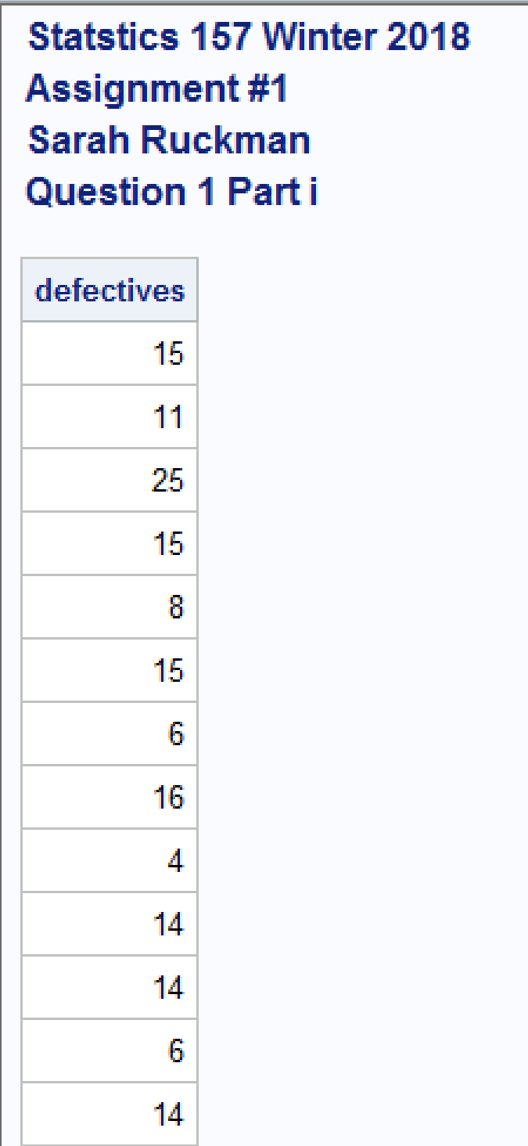 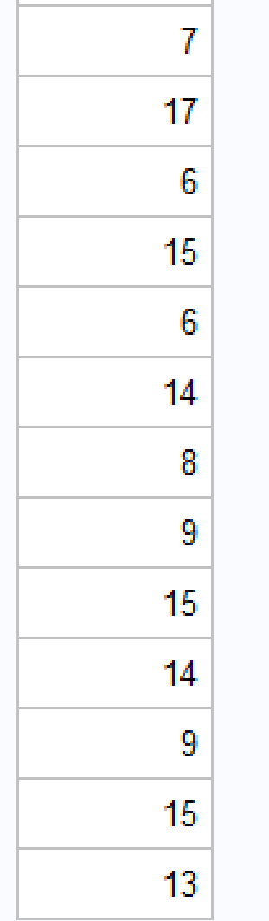

* 1. Create a one-way table for the number of defective chips (2 pts).

**SAS Code:**

options ls = **70** ps = **55** nocenter formdlim = '*';

/* ls = linesize, ps = pagesize, nocenter = justifies output, formdlim = overrides the internal page breaks

and replaces them with the designated symbol */

/* Create titles */

title1 'Statstics 157 Winter 2018';

title2 'Assignment #1';

title3 'Sarah Ruckman';

title4 'Question 1 Part i';

/*Create SAS temporary dataset called quality2 and use an infile statement with firstobs =2 to read in the data*/

**data** quality2;

infile 'C:\Users\sarah\Downloads\QUALITY2_W18.DAT' firstobs=**2**;

/*Use input statement to label variables*/

input defectives;

/*Print as check*/

**proc** **print** noobs;

/*Create a one-way table using the proc freq function and tables with input variable*/

**proc** **freq**;

tables defectives;

/*Change title 4*/

title4 'Question 1 part ii';

**run**;

**quit**;

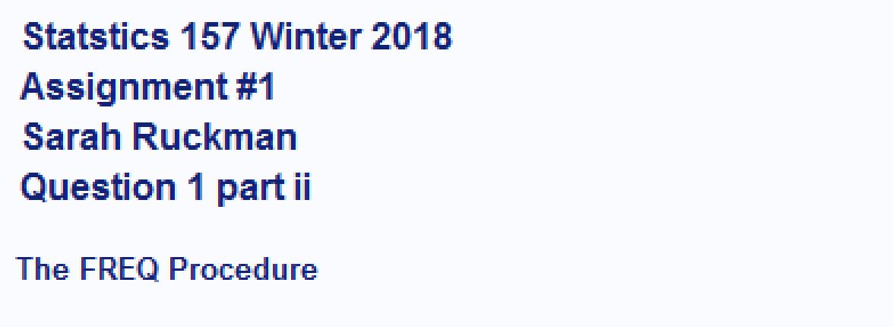

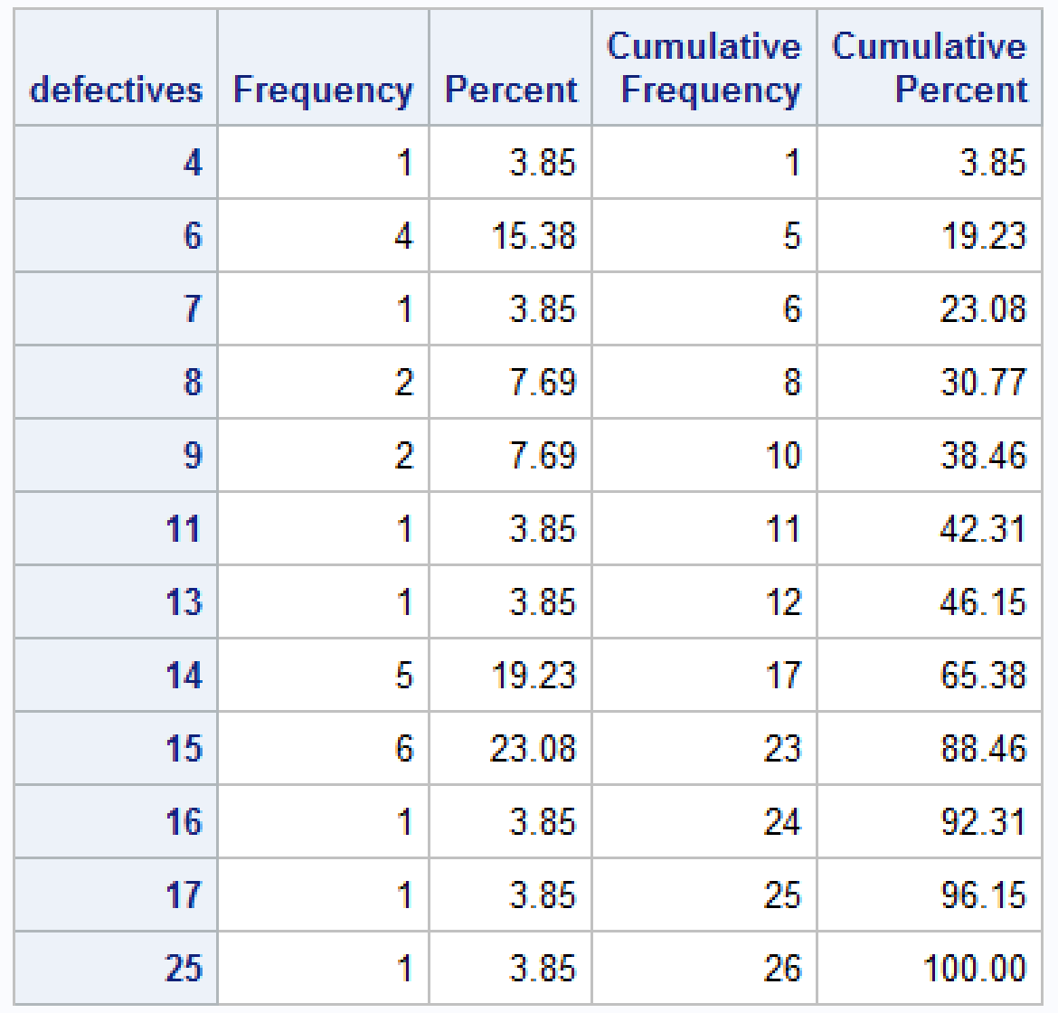

* 1. What is the most common number of defective chips? (1 pt)

**The most common number of defective chips is 15 with 6 times.**

* 1. If a shipment contains more than 15 defective chips, the entire shipment of chips will be sent back to the vendor. How many of the shipments of chips will be returned? (1 pt)

**Three shipments of chips will be returned as they have more than 15 defective chips.**

* 1. Modify your code to determine the average number of defective chips per shipment. (Be sure to identify the answer!) (1 pt)

**SAS Code:**

options ls = **70** ps = **55** nocenter formdlim = '*';

/* ls = linesize, ps = pagesize, nocenter = justifies output, formdlim = overrides the internal page breaks

and replaces them with the designated symbol */

/* Create titles */

title1 'Statstics 157 Winter 2018';

title2 'Assignment #1';

title3 'Sarah Ruckman';

title4 'Question 1 Part i';

/*Create SAS temporary dataset called quality2 and use an infile statement with firstobs =2 to read in the data*/

**data** quality2;

infile 'C:\Users\sarah\Downloads\QUALITY2_W18.DAT' firstobs=**2**;

/*Use input statement to label variables*/

input defectives;

/*Print as check*/

**proc** **print** noobs;

/*Create a one-way table using the proc freq function and tables with input variable*/

**proc** **freq**;

tables defectives;

/*Change title 4*/

title4 'Question 1 part ii';

**proc** **means**;

var defectives;

/*Change title 4*/

title4 'Question 1 Part v';

**run**;

**quit**;

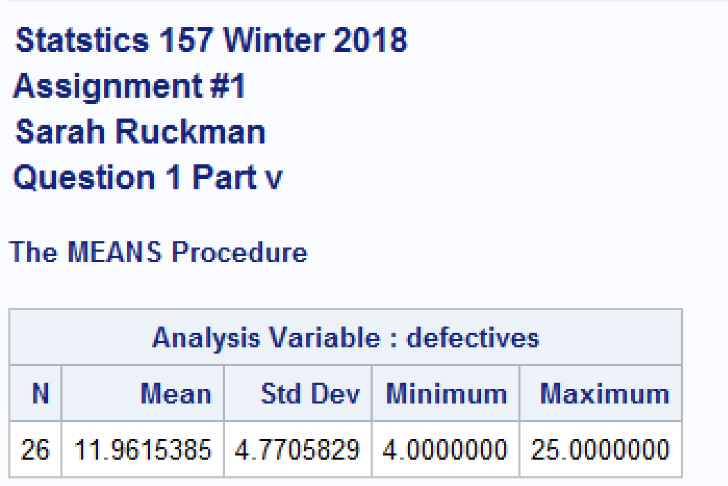

**The average is 11.9615385 defective chips per shipment.**

1. Luke, Shujie and Karen were recently hired by We Want You to Know, a marketing company in the greater Liverslide area. Their first task was to conduct a survey to determine whether there is a relationship between age and ice cream brand preference. They selected a random sample of ice cream lovers and cross-classified them as follows:

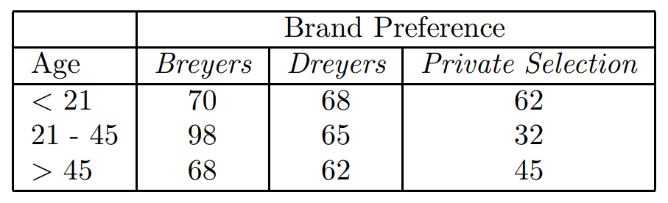

The data is located in a file named icecream1 w18.dat. Complete the following to assist Luke, Shujie and Karen with the analysis.

* 1. Use nested do-loops to read in and print out the data. Use if-then-else structures to give the appropriate names to brand preference and age classification. (5 pts)

**SAS Code:**

options ls = **70** ps = **55** nocenter formdlim = '*';

/* ls = linesize, ps = pagesize, nocenter = justifies output, formdlim = overrides the internal page breaks

and replaces them with the designated symbol */

/* Create titles */

title1 'Statstics 157 Winter 2018';

title2 'Assignment #1';

title3 'Sarah Ruckman';

title4 'Question 1 Part i';

/*Create SAS temporary dataset called quality2 and use an infile statement with firstobs =2 to read in the data*/

**data** quality2;

infile 'C:\Users\sarah\Downloads\QUALITY2_W18.DAT' firstobs=**2**;

/*Use input statement to label variables*/

input defectives;

/*Print as check*/

**proc** **print** noobs;

/*Create a one-way table using the proc freq function and tables with input variable*/

**proc** **freq**;

tables defectives;

/*Change title 4*/

title4 'Question 1 part ii';

**proc** **means**;

var defectives;

/*Change title 4*/

title4 'Question 1 Part v';

/*Create new SAS temporary dataset called IceCream and use an infile statement to read it in firstobs=2*/

**data** IceCream;

infile 'C:\Users\sarah\Downloads\icecream1_w18.dat' firstobs = **2**;

/*Change title4*/

title4 'Question 2 Part i';

/*Read in using do loops do rows then columns*/

do row = **1** to **3**;

/*Use if then else structure to label the rows*/

if row = **1** then age = '< 21 ';

else if row = **2** then age = '21 - 45';

else age = '> 45 ';

/*do columns*/

do brandpref = **1** to **3**;

/*Use if then else structure to label the columns*/

if brandpref = **1** then brand = 'Breyers ';

else if brandpref = **2** then brand = 'Dreyers ';

else brand = 'Private Selection';

/*Use an input statement to read in the data*/

input wt @@;

/*Output the data and close both loops with two end statments*/

output;

end;

end;

/*Print the results*/

**proc** **print** noobs;

**run**;

**quit**;

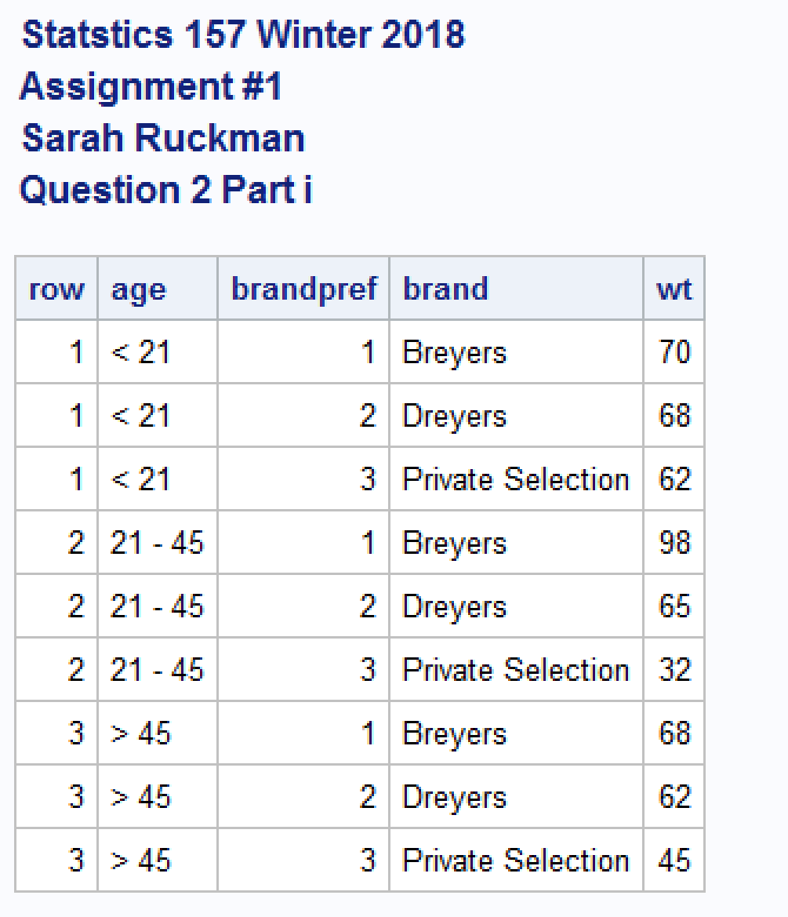

* 1. Modify your code to generate the appropriate χ 2 test of independence information (output). (2 pts)

**SAS Code:**

options ls = **70** ps = **55** nocenter formdlim = '*';

/* ls = linesize, ps = pagesize, nocenter = justifies output, formdlim = overrides the internal page breaks

and replaces them with the designated symbol */

ods graphics off; /*Turns off any extra graphics*/

/* Create titles */

title1 'Statstics 157 Winter 2018';

title2 'Assignment #1';

title3 'Sarah Ruckman';

title4 'Question 1 Part i';

/*Create SAS temporary dataset called quality2 and use an infile statement with firstobs =2 to read in the data*/

**data** quality2;

infile 'C:\Users\sarah\Downloads\QUALITY2_W18.DAT' firstobs=**2**;

/*Use input statement to label variables*/

input defectives;

/*Print as check*/

**proc** **print** noobs;

/*Create a one-way table using the proc freq function and tables with input variable*/

**proc** **freq**;

tables defectives;

/*Change title 4*/

title4 'Question 1 part ii';

**proc** **means**;

var defectives;

/*Change title 4*/

title4 'Question 1 Part v';

/*Create new SAS temporary dataset called IceCream and use an infile statement to read it in firstobs=2*/

**data** IceCream;

infile 'C:\Users\sarah\Downloads\icecream1_w18.dat' firstobs = **2**;

/*Change title4*/

title4 'Question 2 Part i';

/*Read in using do loops do rows then columns*/

do row = **1** to **3**;

/*Use if then else structure to label the rows*/

if row = **1** then age = '< 21 ';

else if row = **2** then age = '21 - 45';

else age = '> 45 ';

/*do columns*/

do brandpref = **1** to **3**;

/*Use if then else structure to label the columns*/

if brandpref = **1** then brand = 'Breyers ';

else if brandpref = **2** then brand = 'Dreyers ';

else brand = 'Private Selection';

/*Use an input statement to read in the data*/

input wt @@;

/*Output the data and close both loops with two end statments*/

output;

end;

end;

/*Print the results*/

**proc** **print** noobs;

/*Use proc freq to generate chi square test with the functions:

wt name of the response variable

nopercent suppresses printing cell percents

norow suppresses printing of row percentages

nocol suppresses printing of column percentages

chisq prints test statistic

expected prints expected frequencies*/

**proc** **freq**;

weight wt;

tables age*brand / chisq expected norow nocol nopercent;

/*Modify title 4*/

title4 'Question 2 Part ii';

**run**;

**quit**;

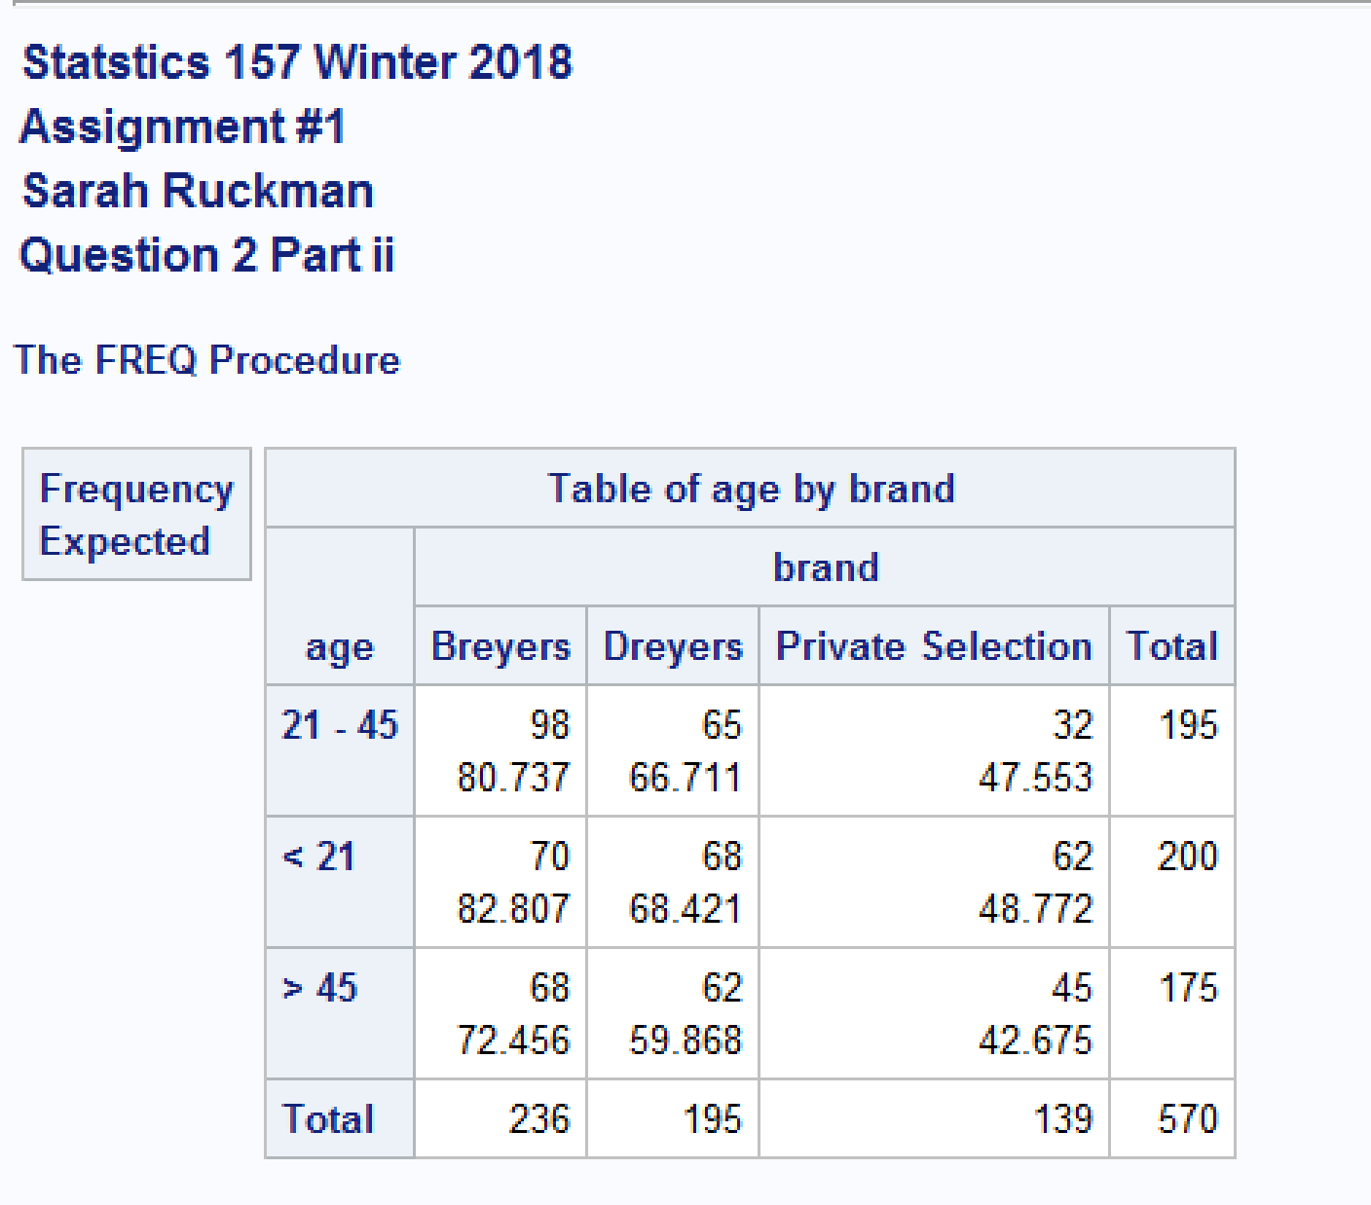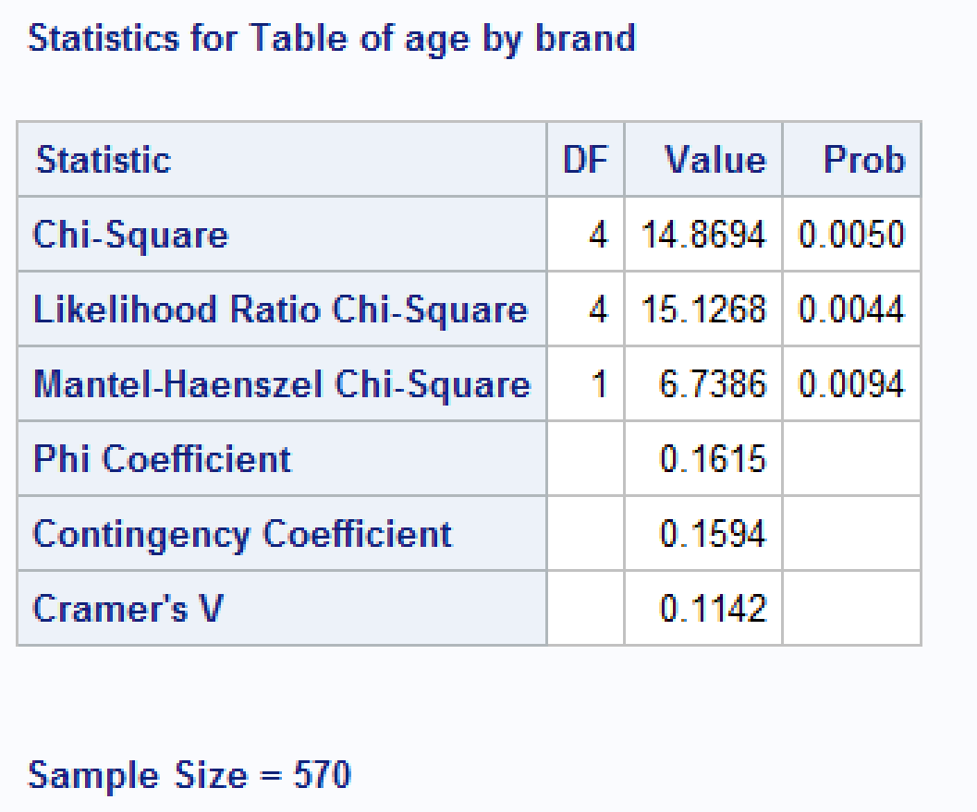

* 1. Perform the appropriate test of hypothesis to determine whether there is a relationship between brand preference and age classification. (4 pts)

**H0: Age class is independent of ice cream brand preference.**

**Ha: There is a relationship between ice cream brand preference and age class.**

**Test Statistic: X2 = 14.8694 with p-value = 0.0050**

**RR: Reject H0 if p-value < α = 0.05**

**Conclusion: Since the p-value = 0.005 is less than α = 0.05, Reject H0 and It is not reasonable to assume age class is independent of ice cream brand preference. (there is a relationship between age class and ice cream brand preference)**

1. Analisa, Wenxiu and Subir work as a quality control engineers for a company that manufactures collegiate football jerseys. They are concerned that the proportion of defective items differs between the day shift and the night shift. They obtain a random sample of data and cross-classify it as follows:

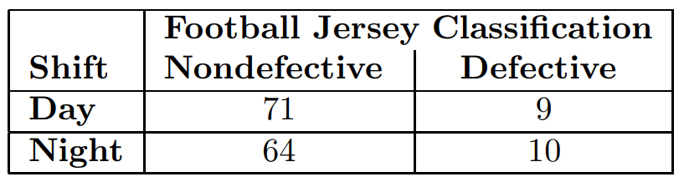

Perform the appropriate test. This data is located in a file named jerseys1 w18.dat.

* 1. Write a SAS program to read in and print out the data. Be sure to use nested do loops! (2 pts)

**SAS Code: (This code was added to the previous code prior to the run statement)**

/*create temporary SAS dataset called jerseys*/

**data** jerseys;

/*Read in the data using an infile statement firstobs = 2*/

infile 'C:\Users\sarah\Downloads\jerseys1_w18.dat' firstobs = **2**;

/*Use do loops to read in the data First do rows then columns*/

do shift = **1** to **2**;

do classification = **1** to **2**;

/*Input the response variable*/

input wt @@;

/*Output the data and close both loops*/

output;

end;

end;

/*Modify title 4*/

title4 'Question 3';

/*Print the results as a check*/

**proc** **print** noobs;

**run**;

**quit**;

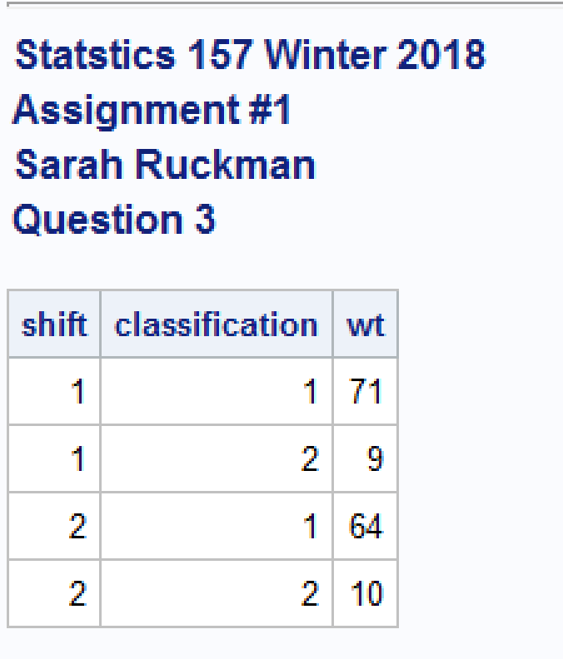

* 1. Use if-then-else structures to name your rows and columns appropriately. (2 pts)

**SAS Code: (This code was added to the previous code prior to the run statement)**

/*create temporary SAS dataset called jerseys*/

**data** jerseys;

/*Read in the data using an infile statement firstobs = 2*/

infile 'C:\Users\sarah\Downloads\jerseys1_w18.dat' firstobs = **2**;

/*Use do loops to read in the data First do rows then columns*/

do shift = **1** to **2**;

/*Use the if then else structure to name the shift time*/

if shift = **1** then time = 'Day ';

else time = 'Night';

do classification = **1** to **2**;

/*Use the if then else structure to name the classification variables*/

if classification = **1** then jersey = 'Nondefective';

else jersey = 'Defective ';

/*Input the response variable*/

input wt @@;

/*Output the data and close both loops*/

output;

end;

end;

/*Modify title 4*/

title4 'Question 3';

/*Print the results as a check*/

**proc** **print** noobs;

**run**;

**quit**;

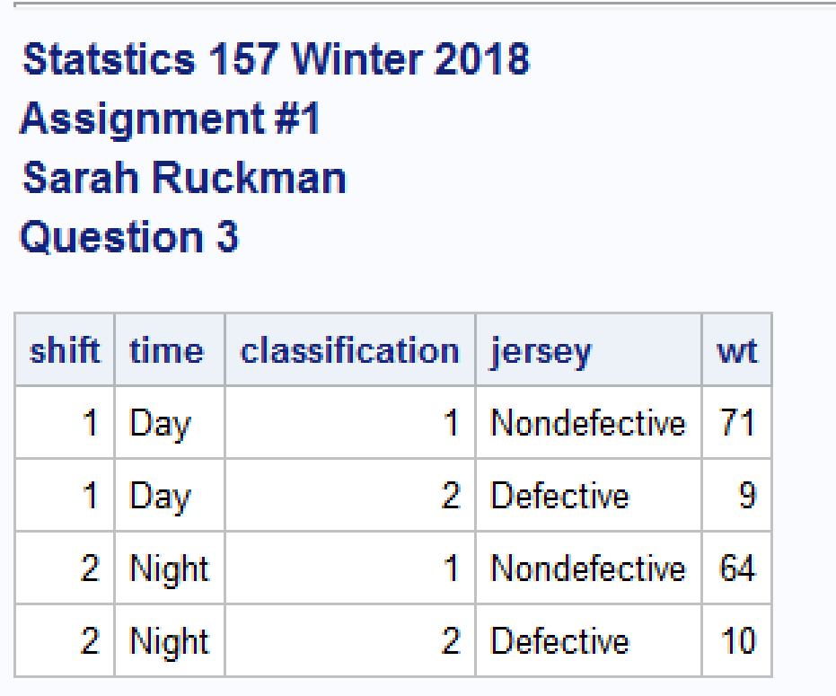

* 1. Modify your code to generate the appropriate χ 2 test of independence information (output). (2 pts)

**SAS Code added prior to run statement:**

/*Use proc freq to generate chi square test with the functions:

wt name of the response variable

nopercent suppresses printing cell percents

norow suppresses printing of row percentages

nocol suppresses printing of column percentages

chisq prints test statistic

expected prints expected frequencies*/

**proc** **freq** order = data;

weight wt;

tables shift*classification / chisq expected norow nocol nopercent;

**run**;

**quit**;

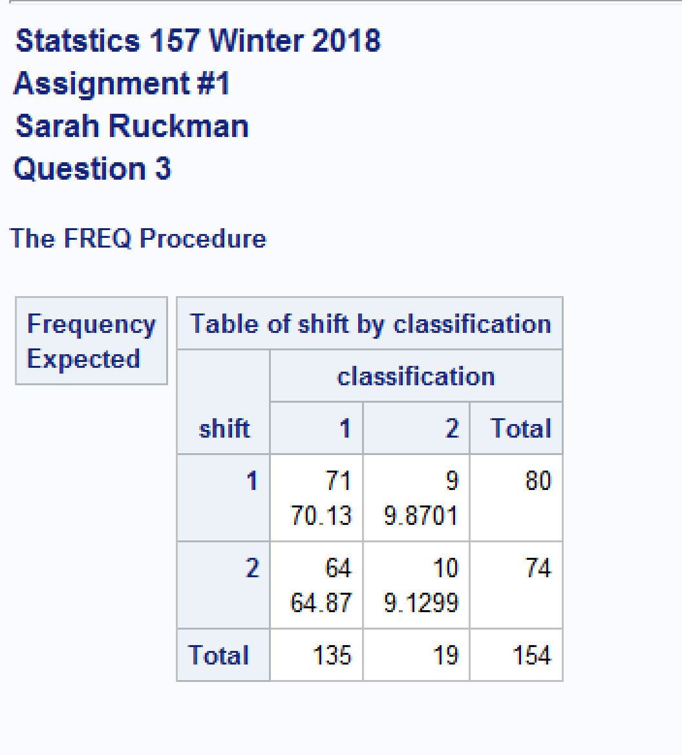

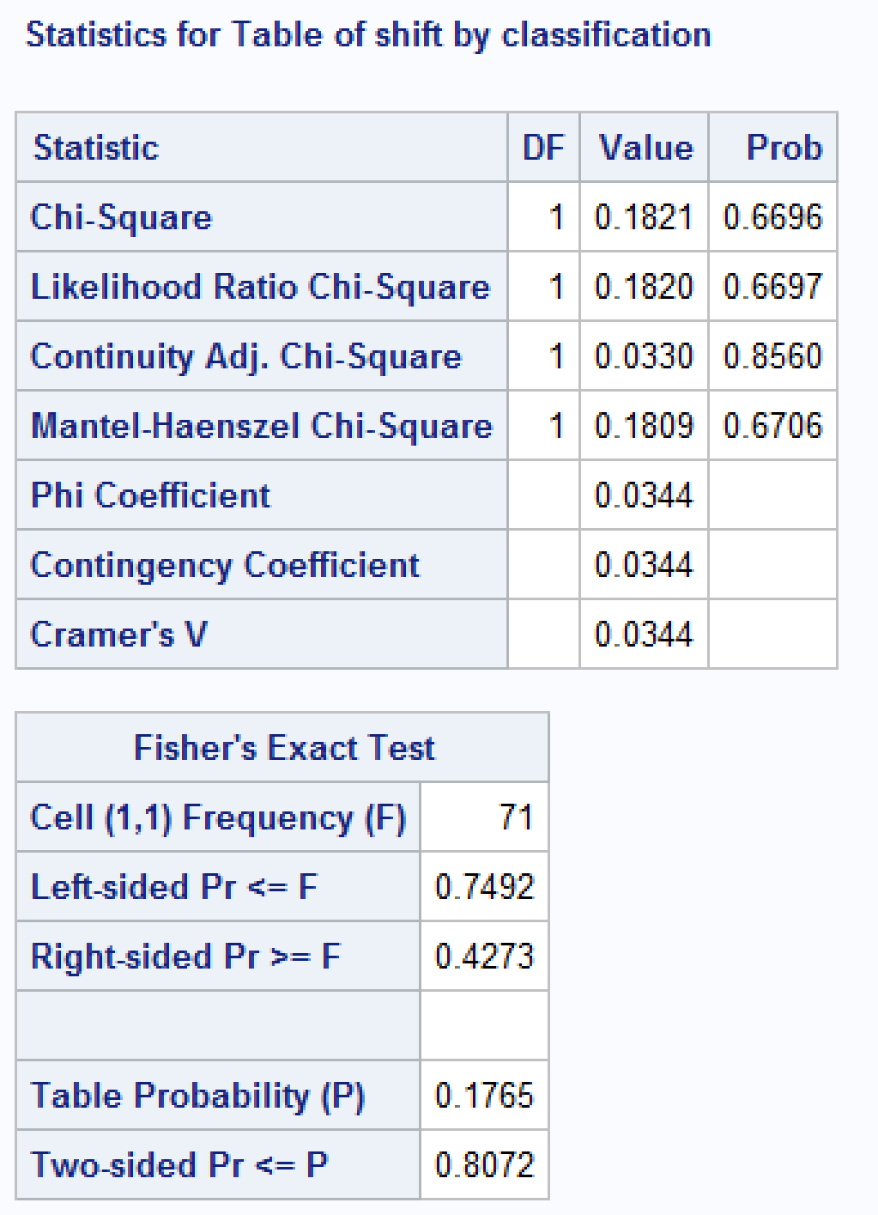



* 1. Perform the appropriate test of hypothesis. (3 pts)

**H0: Shift time is independent of the number of defective jerseys.**

**Ha: There is a relationship between shift time and the number of defective jerseys.**

**TS: Continuity Adj. Chi-Square = 0.0330 with p-value = 0.8560**

**RR: Reject H0 if p-value < α = 0.05**

**Conclusion: Since the p-value = 0.8560 is greater than α = 0.05, We do not reject H0 and it is reasonable to assume shift time is independent of number of defective jerseys.**

1. A national survey stated that 30% of the population prefers to use a pen with black ink, 30% prefer blue ink, 25% prefer red ink and 15% prefer some other color. Jill, Dan and James took a random sample of 80 students and asked them to state their ink color preference. The following data was recorded:

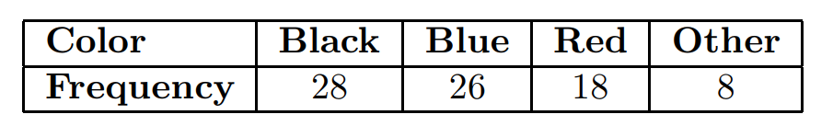

1. Write the SAS code necessary to read in and print out the data. (2 pts)

**SAS Code (Added prior to the run statement)**

/*Create new SAS temporary dataset called pen*/

**data** pen;

/*Input the variable as color $(character variable) and ink for the frequency*/

input color $ ink;

datalines;

black 28

blue 26

red 18

other 8

;

/*Modify title 4*/

title4 'Question 4';

/*Print the results as a check*/

**proc** **print** noobs;

**run**;

**quit**;

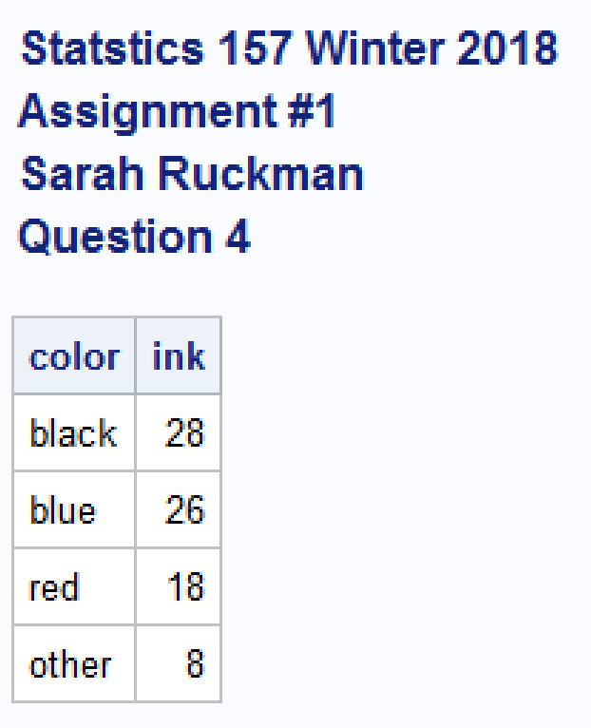

1. Modify the code to generate the appropriate goodness of fit test information (output). (2 pts)

**SAS Code (Added prior to run statement):**

/*Create new SAS temporary dataset called pen*/

**data** pen;

/*Input the variable as color $(character variable) and ink for the frequency*/

input color $ ink;

datalines;

black 28

blue 26

red 18

other 8

;

/*Modify title 4*/

title4 'Question 4';

/*Print the results as a check*/

**proc** **print** noobs;

/*Use the proc freq function with order = data to keep the data together then create a table using the tables function

use the chisq function to do a chisq test and testp with the expected frequencies*/

**proc** **freq** order = data;

tables color / chisq testp = (**30** **30** **25** **15**);

weight ink;

**run**;

**quit**;

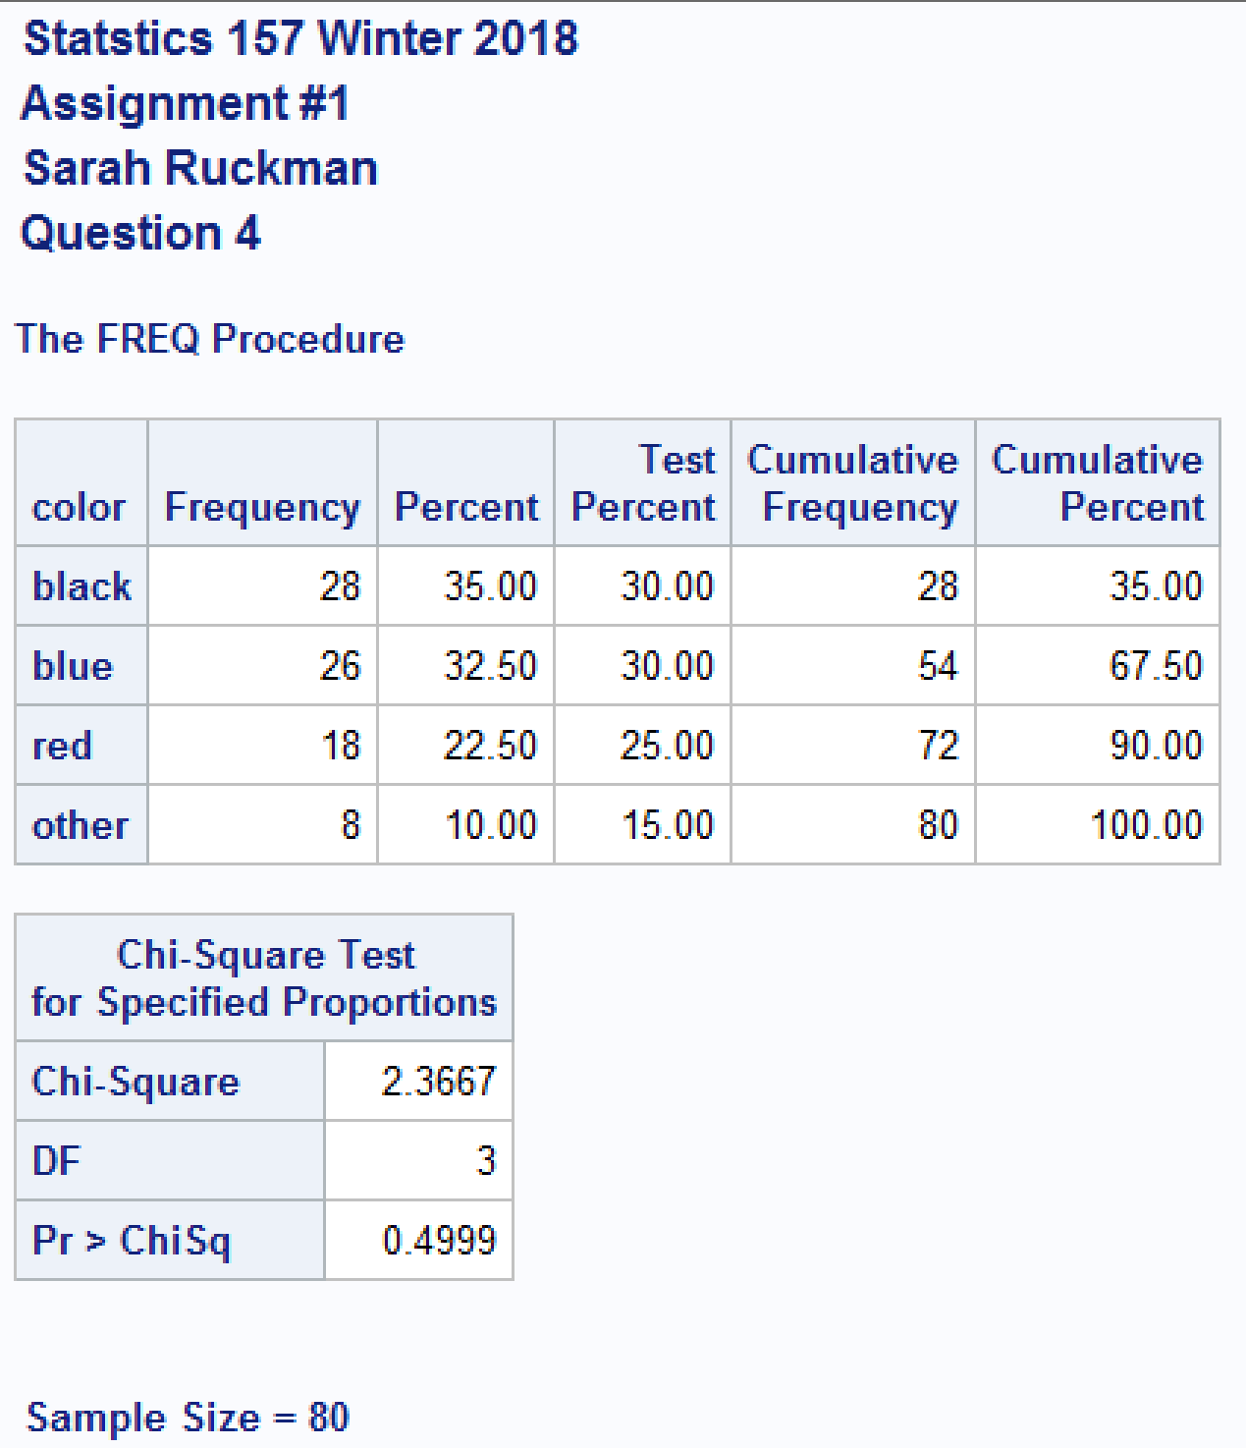

1. Perform the appropriate test of hypothesis, using α = 0.05, to see if it’s reasonable to assume the data supports the national claim. (3 pts)

**H0: pblack = 0.30, pblue = 0.30, pred = 0.25, and pother = 0.15 (national claim)**

**Ha: At least two probabilities differ from the national claim**

**TS: Chi-Square = 2.3667 with p-value = 0.4999**

**RR: Reject H0 if p-value < α = 0.05**

**Conclusion: Since the p-value = 0.4999 is greater than α = 0.05, we do not reject H0 and it is reasonable to assume that data fits the national claim.**

1. Xinping, Yehua and Weixin believe that calls are received at a 24-hour technical support hotline according to a Poisson process with time between calls (interarrival time) follows an exponential distribution with β = 7.5 minutes. They collect the following data:

5.67 11.74 6.53 6.29 8.42 12.12 6.25 5.82 7.40 14.55

The data has been saved in a data file named hotline w18.dat.

* 1. Write the SAS code necessary to read in and print out the data. (3 pts)

**SAS Code (added prior to run statement):**

/*Create new sas temporary dataset called hotline*/

**data** hotline;

/*Use an infile statement with firstobs = 2 to read in the data*/

infile 'C:\Users\sarah\Downloads\HOTLINE_w18.DAT' firstobs = **2**;

/*Input the variable*/

input time;

/*Modify title 4*/

title4 'Question 5';

/*Print as check*/

**proc** **print** noobs;

**run**;

**quit**;

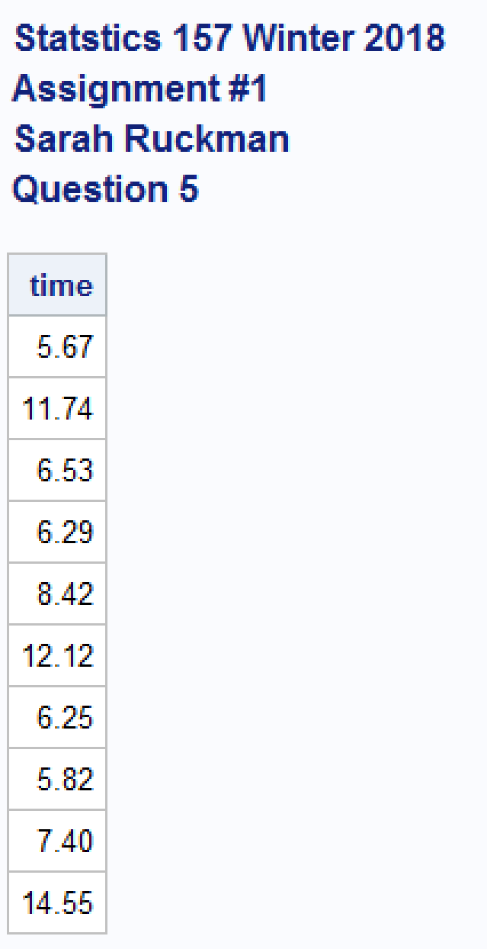

* 1. Modify your code to generate the appropriate information (output) to test the hypothesis that the interarrival time follows an exponential distribution with β = 7.5. (3 pts)

**SAS Code (Added prior to run statement)**

/*Create new sas temporary dataset called hotline*/

**data** hotline;

/*Use an infile statement with firstobs = 2 to read in the data*/

infile 'C:\Users\sarah\Downloads\HOTLINE_w18.DAT' firstobs =**2**;

/*Input the variable*/

input time;

/*Modify title 4*/

title4 'Question 5';

/*Print as check*/

**proc** **print** noobs;

/*Use proc univariate to generate goodness of fit information

ods select GoodnessOfFit suppresses printing of everything except goodness of fit output

histogram / distribution_name(parameter list)*/

**proc** **univariate**;

ods select GoodnessOfFit;

var time;

histogram / exponential(sigma=**7.5**);

**run**;

**quit**;

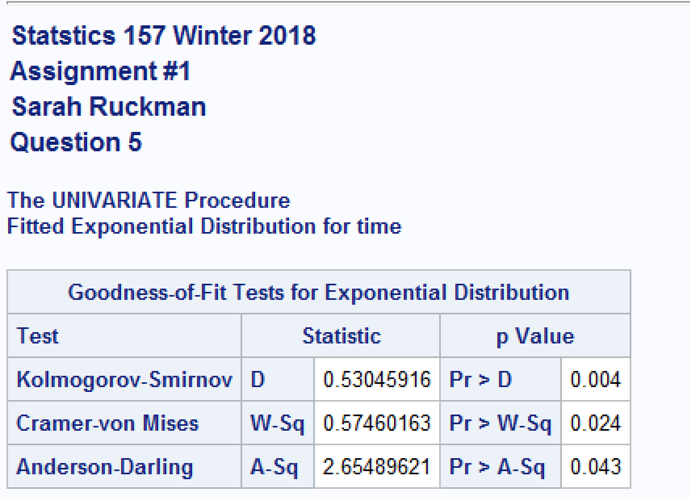

* 1. Perform the appropriate test, using α = 0.05. (4 pts)

**H0: The interarrival time follows an exponential distribution with β = 7.5**

**Ha: The interarrival time does not follow an exponential distribution with β = 7.5**

**TS: Kolmogorov-Smirnov = 0.53045916 with p-value = 0.004**

**RR: Reject H0 if p-value < α = 0.05**

**Conclusion: Since the p-value = 0.004 is less than α = 0.05, we reject H0 and it is not reasonable to assume that the interarrival time follows an exponential distribution with β = 7.5**

1. Linda was interested in determining whether the time to completion of a final exam was normally distributed. She obtained the following random sample of data of completion times (measured in minutes):

116 100 110 85 115 79 75 109 105 80

The data has been saved in completion1 w18.dat.

* 1. Write the SAS code necessary to read in and print out the data. (3 pts)

**SAS Code (Added prior to run statement):**

*Create new sas temporary dataset called completion*/

**data** completion;

/*Use an infile statement with firstobs = 2*/

infile 'C:\Users\sarah\Downloads\completion1_w18.dat' firstobs = **2**;

/*Input the variable time*/

input time;

/*Modify title 4*/

title4 'Question 6';

/*Print as check*/

**proc** **print** noobs;

**run**;

**quit**;

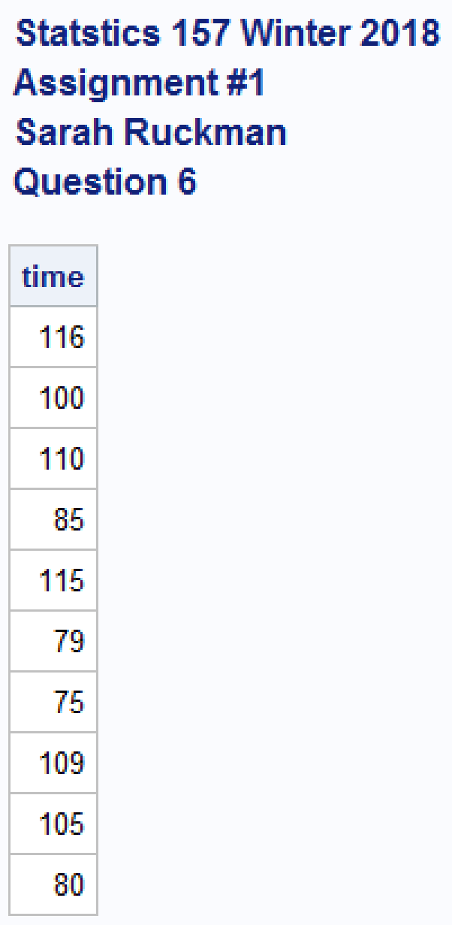

* 1. Modify your code to generate the appropriate information (output) to test the hypothesis that the completion time follows a normal distribution. (3 pts)

**SAS Code (Added prior to run statement):**

/*Create new sas temporary dataset called completion*/

**data** completion;

/*Use an infile statement with firstobs = 2*/

infile 'C:\Users\sarah\Downloads\completion1_w18.dat' firstobs = **2**;

/*Input the variable time*/

input time;

/*Modify title 4*/

title4 'Question 6';

/*Print as check*/

**proc** **print** noobs;

/*Use proc univariate to generate goodness of fit information

ods select GoodnessOfFit suppresses printing of everything except goodness of fit output

histogram / distribution_name(parameter list)*/

**proc** **univariate**;

ods select GoodnessOfFit;

var time;

histogram / normal(mu=est sigma=est);

**run**;

**quit**;

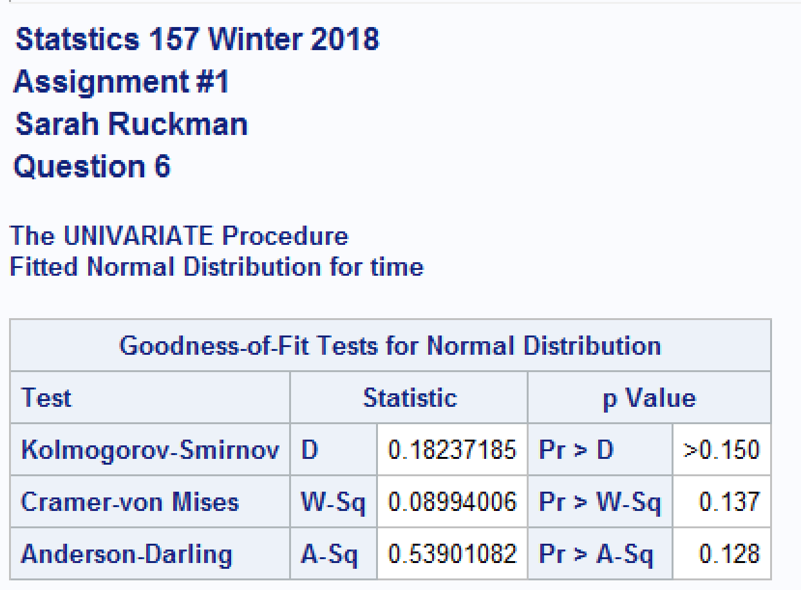

* 1. Perform the appropriate test, using α = 0.05. (4 pts)

**H0: The completion time of a final exam is normally distributed**

**Ha: The completion time of a final exam is not normally distributed**

**TS: Anderson-Darling = 0.53901082 with p-value= 0.128**

**RR: Reject H0 if the p-value < α =0.05**

**Conclusion: Since the p-value = 0.128 is greater than α = 0.05, we do not reject H0 and it is reasonable to assume that the completion time of a final exam is normally distributed.**

**Complete SAS Code:**

options ls = **70** ps = **55** nocenter formdlim = '*';

/* ls = linesize, ps = pagesize, nocenter = justifies output, formdlim = overrides the internal page breaks

and replaces them with the designated symbol */

ods graphics off; /*Turns off any extra graphics*/

/* Create titles */

title1 'Statstics 157 Winter 2018';

title2 'Assignment #1';

title3 'Sarah Ruckman';

title4 'Question 1 Part i';

/*Create SAS temporary dataset called quality2 and use an infile statement with firstobs =2 to read in the data*/

**data** quality2;

infile 'C:\Users\sarah\Downloads\QUALITY2_W18.DAT' firstobs=**2**;

/*Use input statement to label variables*/

input defectives;

/*Print as check*/

**proc** **print** noobs;

/*Create a one-way table using the proc freq function and tables with input variable*/

**proc** **freq**;

tables defectives;

/*Change title 4*/

title4 'Question 1 part ii';

**proc** **means**;

var defectives;

/*Change title 4*/

title4 'Question 1 Part v';

/*Create new SAS temporary dataset called IceCream and use an infile statement to read it in firstobs=2*/

**data** IceCream;

infile 'C:\Users\sarah\Downloads\icecream1_w18.dat' firstobs = **2**;

/*Change title4*/

title4 'Question 2 Part i';

/*Read in using do loops do rows then columns*/

do row = **1** to **3**;

/*Use if then else structure to label the rows*/

if row = **1** then age = '< 21 ';

else if row = **2** then age = '21 - 45';

else age = '> 45 ';

/*do columns*/

do brandpref = **1** to **3**;

/*Use if then else structure to label the columns*/

if brandpref = **1** then brand = 'Breyers ';

else if brandpref = **2** then brand = 'Dreyers ';

else brand = 'Private Selection';

/*Use an input statement to read in the data*/

input wt @@;

/*Output the data and close both loops with two end statments*/

output;

end;

end;

/*Print the results*/

**proc** **print** noobs;

/*Use proc freq to generate chi square test with the functions:

wt name of the response variable

nopercent suppresses printing cell percents

norow suppresses printing of row percentages

nocol suppresses printing of column percentages

chisq prints test statistic

expected prints expected frequencies*/

**proc** **freq**;

weight wt;

tables age*brand / chisq expected norow nocol nopercent;

/*Modify title 4*/

title4 'Question 2 Part ii';

/*create temporary SAS dataset called jerseys*/

**data** jerseys;

/*Read in the data using an infile statement firstobs = 2*/

infile 'C:\Users\sarah\Downloads\jerseys1_w18.dat' firstobs = **2**;

/*Use do loops to read in the data First do rows then columns*/

do shift = **1** to **2**;

/*Use the if then else structure to name the shift time*/

if shift = **1** then time = 'Day ';

else time = 'Night';

do classification = **1** to **2**;

/*Use the if then else structure to name the classification variables*/

if classification = **1** then jersey = 'Nondefective';

else jersey = 'Defective ';

/*Input the response variable*/

input wt @@;

/*Output the data and close both loops*/

output;

end;

end;

/*Modify title 4*/

title4 'Question 3';

/*Print the results as a check*/

**proc** **print** noobs;

/*Use proc freq to generate chi square test with the functions:

wt name of the response variable

nopercent suppresses printing cell percents

norow suppresses printing of row percentages

nocol suppresses printing of column percentages

chisq prints test statistic

expected prints expected frequencies*/

**proc** **freq** order = data;

weight wt;

tables shift*classification / chisq expected norow nocol nopercent;

/*Create new SAS temporary dataset called pen*/

**data** pen;

/*Input the variable as color $(character variable) and ink for the frequency*/

input color $ ink;

datalines;

black 28

blue 26

red 18

other 8

;

/*Modify title 4*/

title4 'Question 4';

/*Print the results as a check*/

**proc** **print** noobs;

/*Use the proc freq function with order = data to keep the data together then create a table using the tables function

use the chisq function to do a chisq test and testp with the expected frequencies*/

**proc** **freq** order = data;

tables color / chisq testp = (**30** **30** **25** **15**);

weight ink;

/*Create new sas temporary dataset called hotline*/

**data** hotline;

/*Use an infile statement with firstobs = 2 to read in the data*/

infile 'C:\Users\sarah\Downloads\HOTLINE_w18.DAT' firstobs = **2**;

/*Input the variable*/

input time;

/*Modify title 4*/

title4 'Question 5';

/*Print as check*/

**proc** **print** noobs;

/*Use proc univariate to generate goodness of fit information

ods select GoodnessOfFit suppresses printing of everything except goodness of fit output

histogram / distribution_name(parameter list)*/

**proc** **univariate**;

ods select GoodnessOfFit;

var time;

histogram / exponential(sigma=**7.5**);

/*Create new sas temporary dataset called completion*/

**data** completion;

/*Use an infile statement with firstobs = 2*/

infile 'C:\Users\sarah\Downloads\completion1_w18.dat' firstobs = **2**;

/*Input the variable time*/

input time;

/*Modify title 4*/

title4 'Question 6';

/*Print as check*/

**proc** **print** noobs;

/*Use proc univariate to generate goodness of fit information

ods select GoodnessOfFit suppresses printing of everything except goodness of fit output

histogram / distribution_name(parameter list)*/

**proc** **univariate**;

ods select GoodnessOfFit;

var time;

histogram / normal(mu=est sigma=est);

**run**;

**quit**;